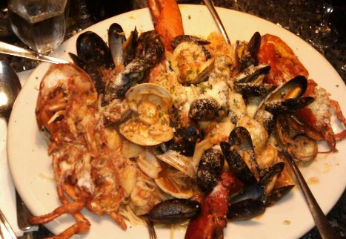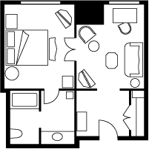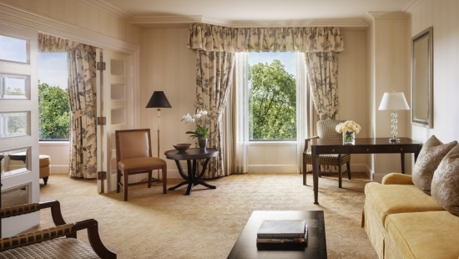 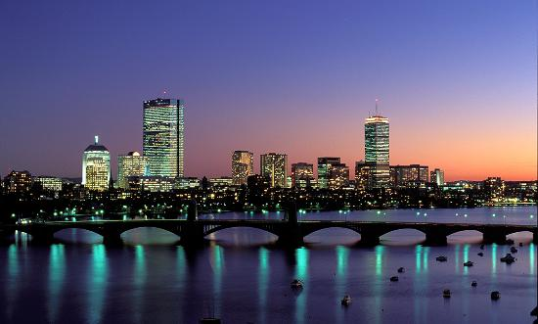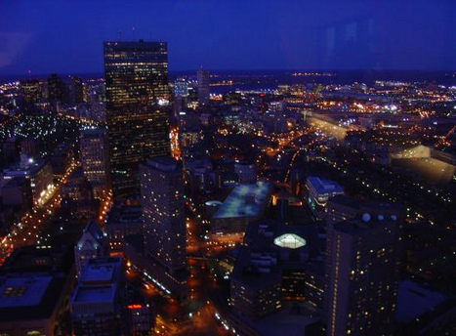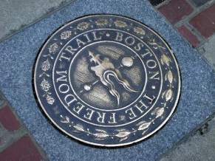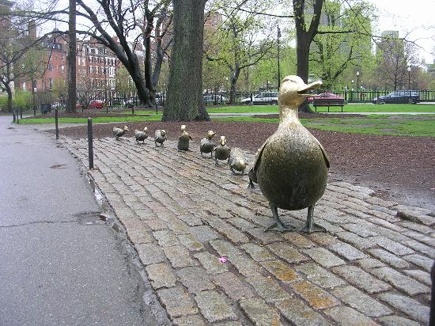

November 22, 2013

Jet Blue Flight: 56

Departs Dulles: 9:47a

Arrives Boston: 11:11a

November 24, 2013

Jet Blue Flight 1257

Departs Boston: 6:35p

Arrives Dulles: 8:16p

Total Cost of Flight for 3 people: $955

Flight Information

November 22-24, 2013

I picked Giacoma’s restaurant because our family loves the North End and eating Italian food. This restaurant got great reviews and there’s lots of great seafood dishes on the menu.

The restaurant is very popular and they don’t take reservations, so we need to get there at 4:30p when it opens. Reviewers said the line to wait can be 2 hours long. They only take cash and there’s NO dessert. We’ll have to walk around afterwards to find a bakery for cannoli’s.

I can’t wait for you to see this hotel. Since price was no object for this project, we’re staying at the Four Seasons Hotel in Boston. It is a five star hotel and rated the number 3 family hotel in Trip Advisor with 714 reviews. We have suite, so I get my own room! The location couldn’t be better. The hotel is in Boston’s Back Bay and overlooks the Boston Gardens. Based on reviews, the hotel staff is very friendly and they welcome children. Sometimes they even give you a stuffed animal when you check-in!

355 Hanover Street

Boston, MA 02113-1920

Phone: 617-523-9026

Website: http://giacomosblog-boston.blogspot.com/

# Giacoma’s Restaurant

#### Four Seasons Hotel

# Chaleki Family Get Away

**Boston, Massachusetts**

Skywalk Observatory view of Boston at night

# Freedom Trail

Because we like to be outside and active, we are going to take a 2 hour walking tour of the Freedom Trail. We’ll get to see a lot of historical sites such as Quincy Market, Faneuil Hall, Boston Common , The North End, Paul Revere's House, USS Constitution and a lot more.

“One if by land

Two if by sea”

# Old North Church

We have to visit the Old North Church because of its importance in the American Revolution.

# Boston Public Gardens

We have to visit Boston Public Gardens, since our hotel is across from it. It was ranked the 7th best park in America by the Trip Advisor website. If the weather is good, we can take a swan boat and feed the ducks. We don’t want to miss the “Make Way for Ducklings” statue. The park will be a nice place to relax after a busy day in the city.

Boston Public Gardens

Make Way for Ducklings

#### Activities

# Museum of Science

Going to the Museum of Science is a family tradition. There are a lot of hands on activities and everyone learns something.

# Skywalk Observatory

The Skywalk Observatory is on the 50th floor of the Prudential building. You can get a 360 degree view of the city. Let’s go at sunset so we can see the sun set over Boston and then see it all lit up at night.